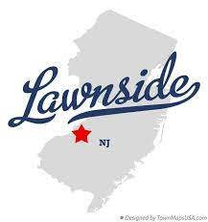TRASH COLLECTION HOLIDAY SCHEDULE
TRASH COLLECTED ON TUESDAY, 5/31/2022

TRASH COLLECTED ON TUESDAY, 7/5/2022

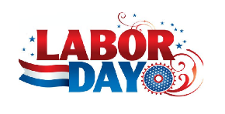 TRASH COLLECTED ON TUESDAY, 9/6/2022

TRASH COLLECTED ON MONDAY, 11/28/2022

TRASH COLLECTED ON TUESDAY, 12/27/2022

TRASH COLLECTED ON TUESDAY, 1/3/2023

