Please complete this application in ink. Please print legibly or type. Only fully completed applications will be considered.
Approved: Not Approved:

Please indicate usage information:
C] Individual Resident
Individual Non-Resident
Non-Profit Community Organization
Non-Profit Organization
Please attach proof of residency such as current tax or utility bill and insurance (see below.)
Insurance (see below.)
Please attach proof of 501(c)(3) or nonprofit status and insurance(see below.)
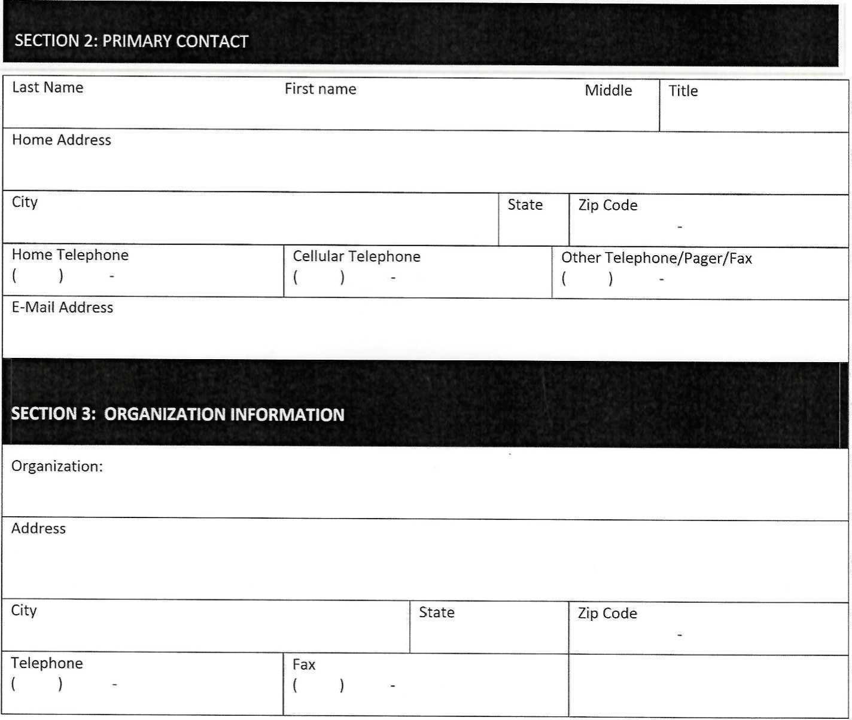
Please attach proof of 501(c)(3) or nonprofit status and insurance (see below.)

Please indicate what type of use you are proposing:
C] Single Event C] Recurring Event Single Event:
Date of Usage | Start Time | End Time
Recurring Event:
Start Date | End Date | MON  TUE  WED  THR | FRI SAT  SUN
Start Time | End Time

By signing below, I agree to obey all rules, regulations and ordinances and to be responsible for the condition and maintenance of the facility and proper behavior of guests. I will be totally and solely responsible for any damages done to the facility. I will be in attendance at the field for the duration of the event. To the fullest extent permitted by law, I agree to defend, pay on behalf of, indemnify, and hold harmless the Borough of Lawnside, its elected and appointed officials, its agents, employees and volunteers and others working on behalf of the Borough of Lawnside and against any and all claims, demands, suits, or loss, including all costs connected therewith, for any damages which may be asserted, claimed or recovered against or from the Borough of Lawnside, its elected and appointed officials, its agents, employees, volunteers or others working on behalf of the Borough of Lawnside, by reason of personal injury, including bodily injury or death and/or property damage, including loss of use thereof, which arises out Of or is in any way connected or associated with this contract.
Applicant's Name | Applicant's Signature | Date
FAILURE TO COMPLY WITH THESE REGULATIONS
WILL RESULT IN THE LOSS OF PRIVILEGES TO USE THE FACILITY
FIELD USAGE RULES AND REGULATIONS
[1 | ONLY EMERGENCY RESPONSE OR MAINTENANCE VEHICLES ALLOWED BEYOND PARKING FACILITIES.  Lawnside Officials/Recreation Committee reserves the right to cancel field usage at any time due to field conditions or unforeseen circumstances.  Inappropriate behavior will not be tolerated and no loud talking or inconsiderate behavior while outside.  Field must be cleaned after each usage and trash must be deposited in appropriate containers located on the field.  The Borough of Lawnside is not responsible for lost or damaged equipment or belongings.  Alcoholic beverages are not permitted. No smoking in or around fields.  The Borough is not responsible for loss or theft of personal items from the building or vehicles. Please ensure your guests safeguard their items.  There is no public address system available.  No person shall engage in any commercial or fund-raising enterprise, including but not limited to offering of services, soliciting, selling or peddling any liquids or edibles for human consumption, unless they have obtain approval from Borough Council. Nor may they distribute any circulars or papers; or hawk, peddle, raffle, or vend such any goods, wares or merchandise within a park or recreation facilities, except when such action is approved by the Borough Council and all appropriate licenses have been issued by other authorities or agencies as required.  No person shall fasten any bill, advertisement, pamphlet, or inscription within a Borough park or recreation area, without written permission of the Borough Council.
VIOLATION OF FIELD USAGE RULES AND REGULATIONS:
Any teams/managers found in violation of the above rules and regulations will be given a warning in the form of a letter addressed to the governing board and with a copy provided to the Borough of Lawnside Recreation Committee. Appropriate disciplinary action will be determined by these parties. Fines will be issued for leaving litter on fields, bleachers and the parking area. In addition to a letter to the governing boards, the coach or manager may be required to attend an inquiry in front of the Borough of Lawnside Recreation Committee which could ultimately result in the suspension of field privileges.
I have read and fully understand the above stated rules and regulations and agree to follow them.
Applicant's Name | Applicant's Signature | Date

Insurance Requirements:

Please attach your certificate of insurance naming- THE BOROUGH OF LAWNSIDE as an additional insured with the follwing specification:

  - Workers Compensation/Employers Liability:Statutory/ $500,000.00
  - General Liability: $1000,000.00
  - Automobile Liabilty: $1,000,000.00
  - Umbrella Liability: $1,000,000.00/$2,000,000.00

